RESUME
PRABHAKAR RAM  Contact:-+919454481912  E-mail:-prabhakarramrock@gmail.com  Present Address:- 223221, Azamgarh, Uttar Pradesh | 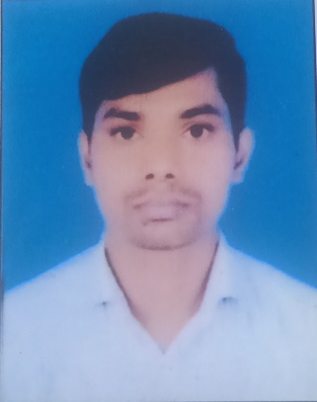

CAREER OBJECTIVE
- Seeking a rewarding opportunity with an organization committed to fostering the growth of knowledge workers. Eager to immerse myself in a dynamic environment that nurtures continuous learning and equips me with the skills to confidently navigate and overcome diverse professional challenges. Excited to contribute my enthusiasm and dedication to achieving both personal and organizational success.

BASIC ACADEMIC CREDENTIALS

Qualification | Board/University | Year | Division
B.A. | V.P.S. Purvanchal University, Jaunpur | 2012 | IInd
Intermediate | UP Board Allahabad | 2009 | Ind
High School | UP Board Allahabad | 2007 | IInd

SOFT SKILLS
- Comprehensive problem solving abilities.
- A self motivated candidate with a good learning skill.
- Excellent verbal and written communication skills.

Technical SKILLS
- ITI Passed with fitter trade from S.C.Private ITC - Azamgarh UP in 2019

Certification
- CCC - NIELIT - June/ 2019 With C Grade

EXPERIENCE
Company :- E01162300007-NORTHERN COALFIELD
LIMITED
Address :- SINGRAULI, Madhya Pradesh
Job Type :- APPRENTICESHIP
Trade :- Fitter
Sector :- Production and Manufacturing
Duration :- From 08-02-2021 to 07-02-2022

EXPERIENCE
Company :- Electronics Corporation of India Limited.
Address :- Hyderabad, Telangana.
Designation :- Junior Technician (on Contract)
Job Type :- Full Time
Division :- Electronic Manufacturing Services Division
Duration :- 08/11/2022 to 07/11/2023

PERSONAL DETAILS

- Name :- Prabhakar Ram
- Father’s Name :- Mr. Ram Achal Ram
- Permanent Address :- Azamgarh UP(223221)
- Date of Birth :- 01/09/1991
- Language Known :- English & Hindi
- Marital Status :- Married
- Nationality/Religion :- Indian /Hindu

DECLARATION

I do hereby declare that the above information is true to the best of my knowledge.

Place: Azamgarh
Date: (Signature)

